**Project : Capstone I**

You have been hired as a Sr. DevOps Engineer in Abode Software. They want to

implement DevOps Lifecycle in their company. You have been asked to

implement this lifecycle as fast as possible. Abode Software is a product-based

company and their product is available on this GitHub link.

https://github.com/hshar/website.git

Following are the specifications of the lifecycle:

1. Install the necessary software on the machines using a configuration

management tool

2. Git workflow has to be implemented

3. CodeBuild should automatically be triggered once a commit is made to

master branch or develop branch.

a. If a commit is made to master branch, test and push to prod

b. If a commit is made to develop branch, just test the product, do not

push to prod

4. The code should be containerized with the help of a Dockerfile. The

Dockerfile should be built every time there is a push to GitHub. Use the

following pre-built container for your application: hshar/webapp

The code should reside in '/var/www/html'

5. The above tasks should be defined in a Jenkins Pipeline with the following

jobs:

a. Job1 : build

b. Job2 : test

c. Job3 : prod

sol:

* Step1 - Created 3 instances named Master, Test and Prod.
* Step2 – Installed Ansible in the Master node.
* Step3 – copied the pub key of master and pasted that in the authorized_key file of slaves.
* Step4 – Mentioned the private IP of slaves in the Master /etc/ansible/hosts.
* Step5 – able to ping successfully to the slaves through Master.
* Step6 – wrote a playbook for installing necessary packages in the master and the slave.

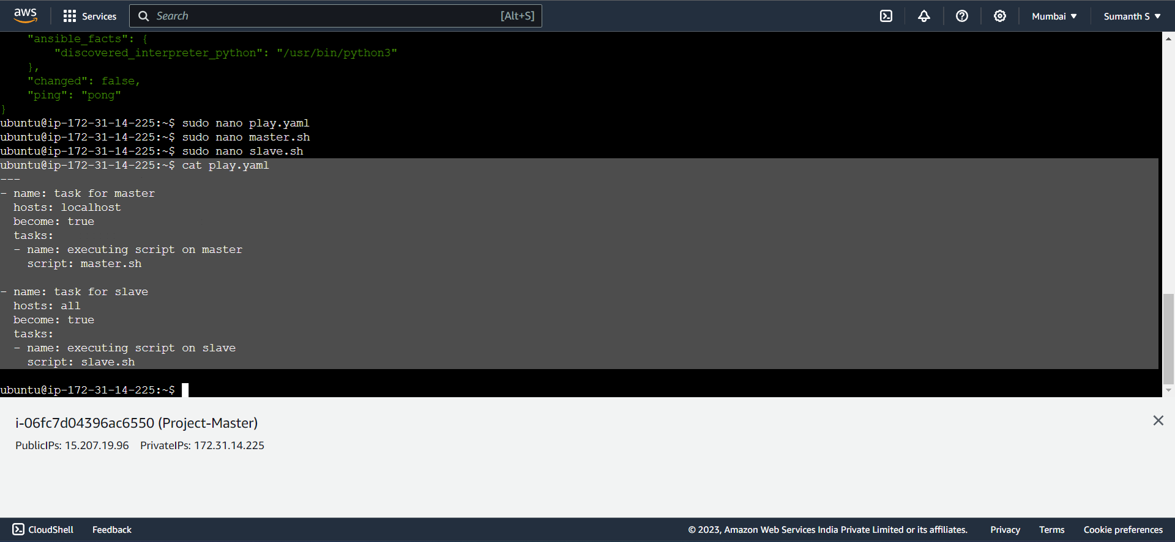

* Step7 – Created master.sh for installing Jenkins in the master.

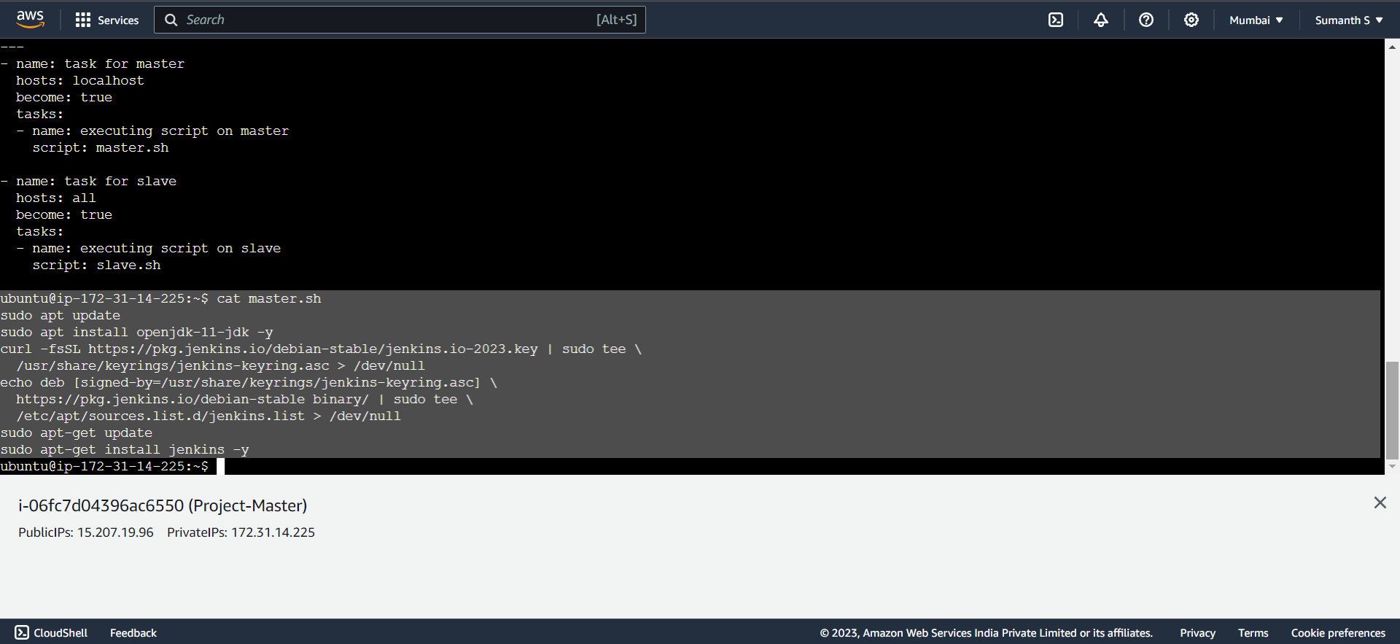

* Step8 – Created slave.sh for installing java and docker in the slave nodes.

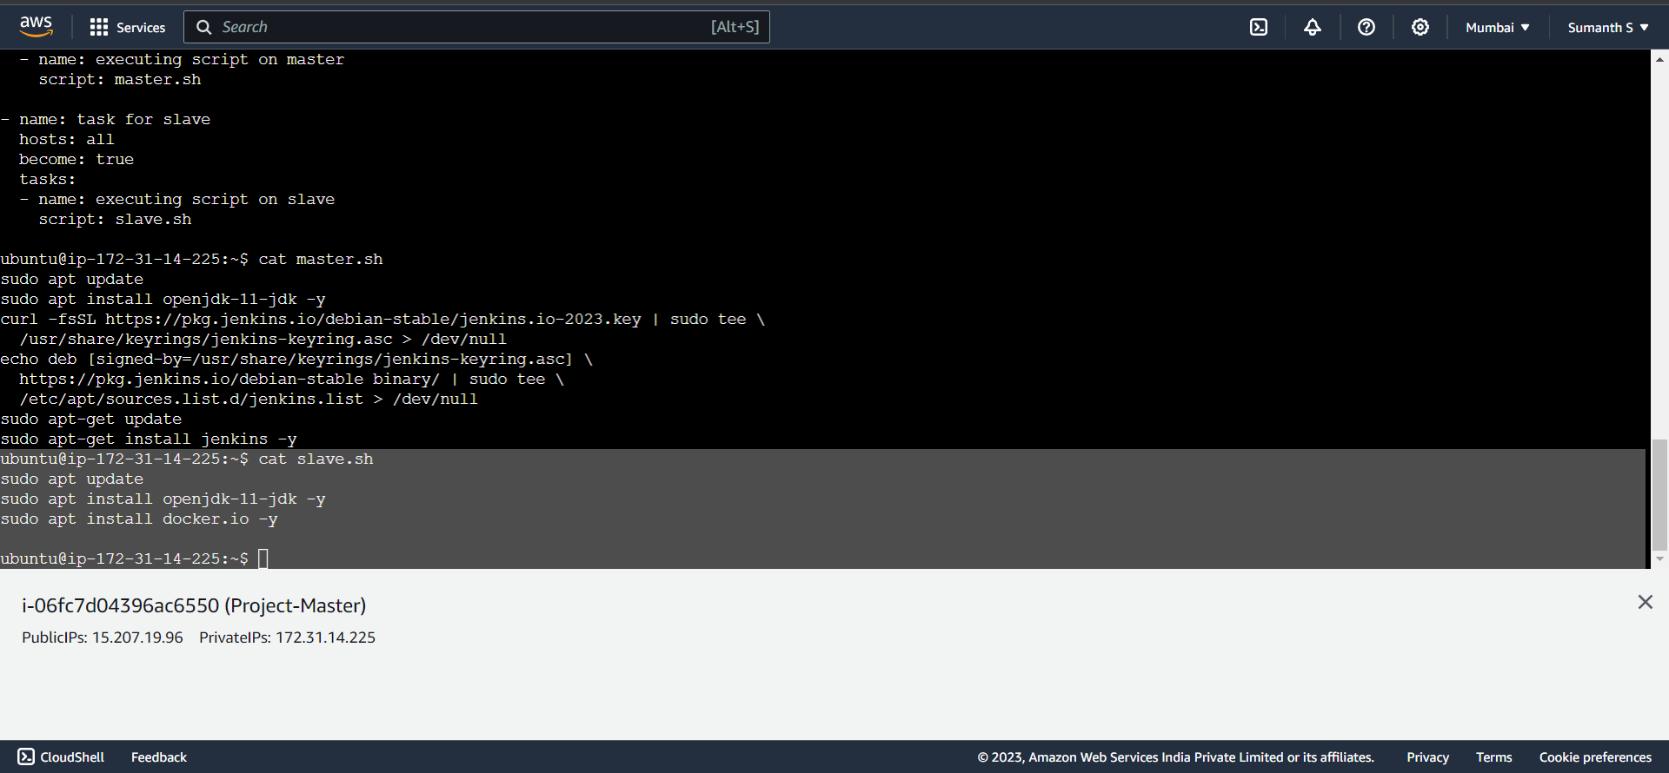

* Step9 – Installed all the necessary packages in the master as well as slave.

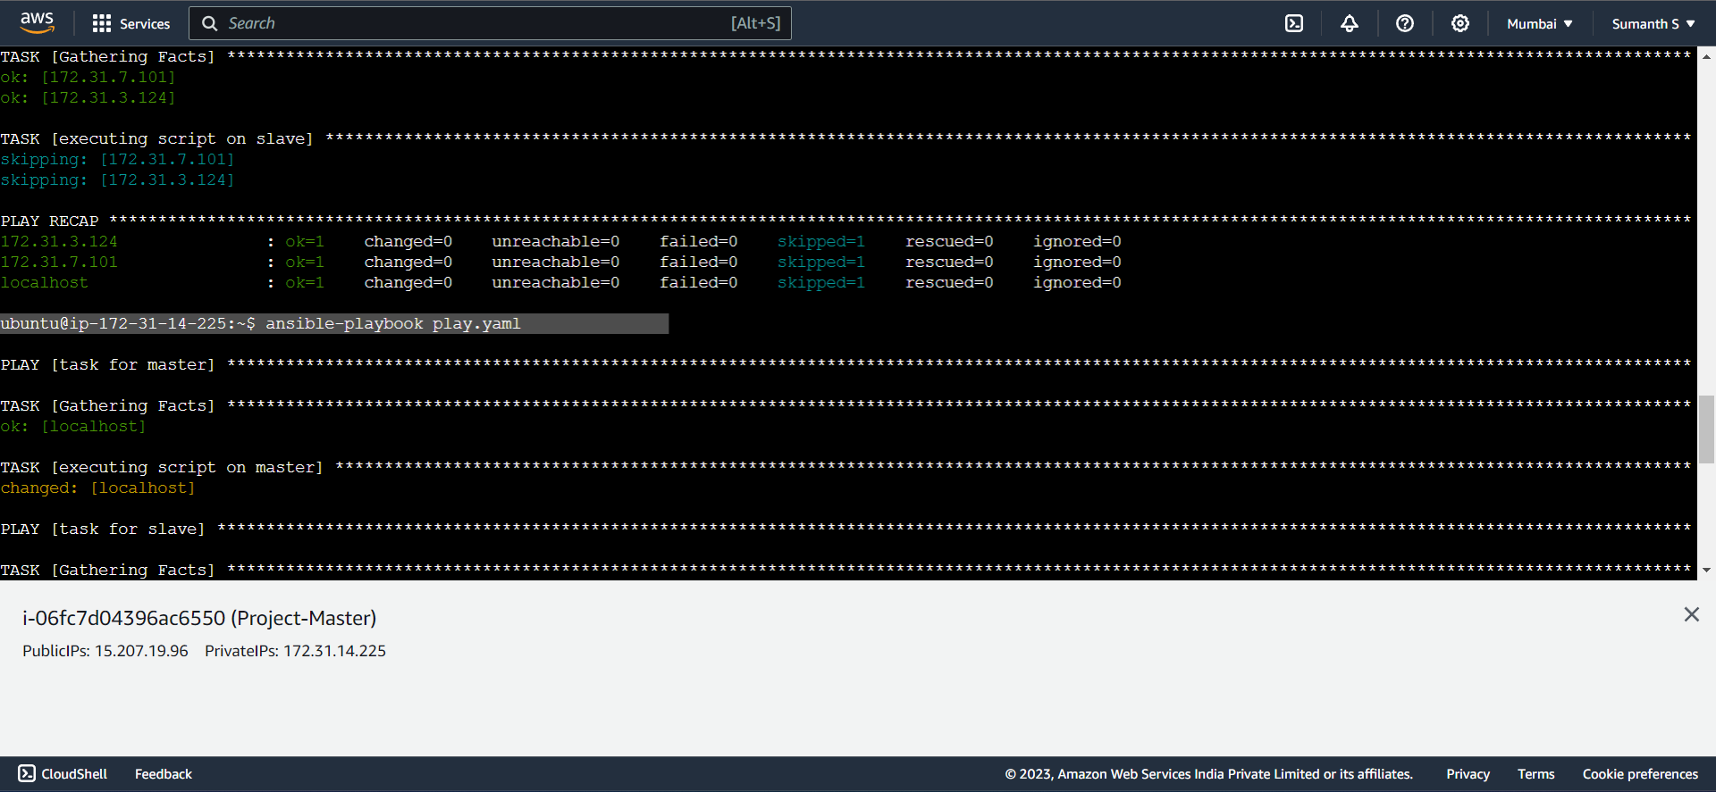

* Step10 – Logged into Jenkins and connected our slave nodes to it.

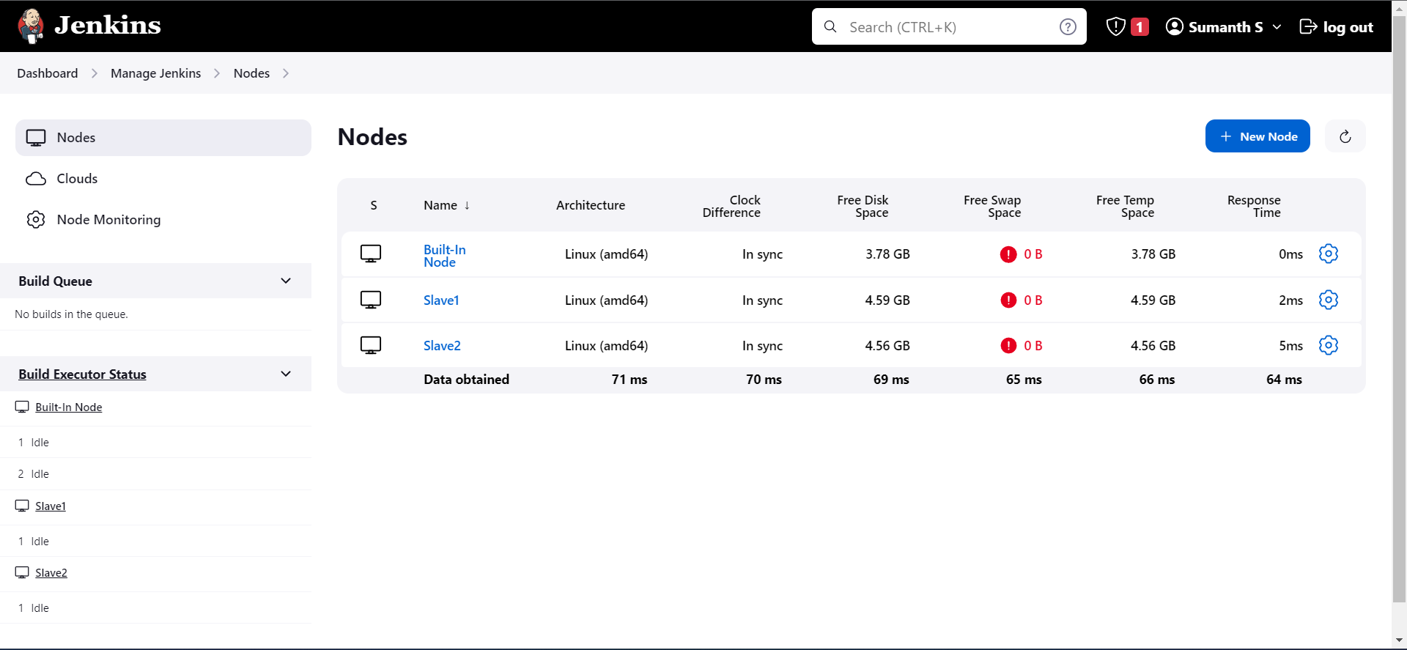

* Step11 – Created a Docker file and a new branch ‘develop’.

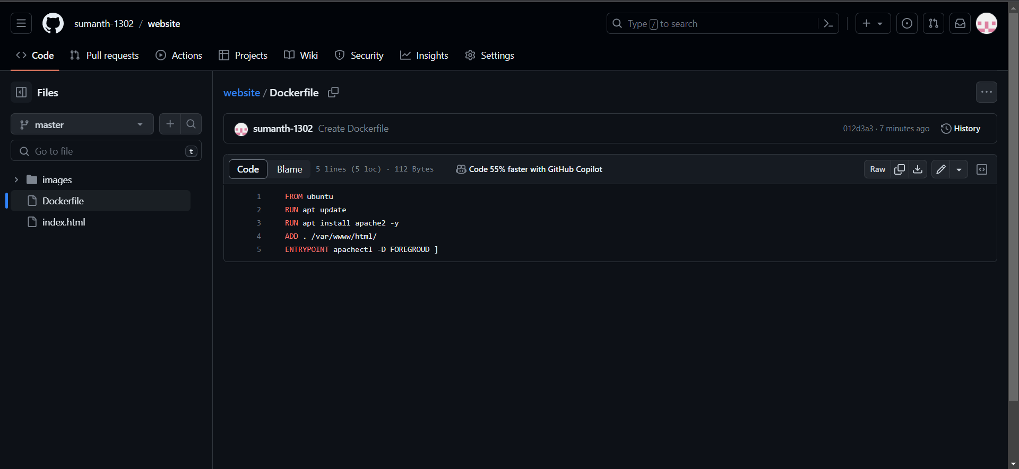

* Step12 -